Install MySQL on Ubuntu

Step 1 — Installing MySQL
On Ubuntu 18.04, only the latest version of MySQL is included in the APT package repository by default. At the time of writing, that’s MySQL 5.7
To install it, update the package index on your server with apt:
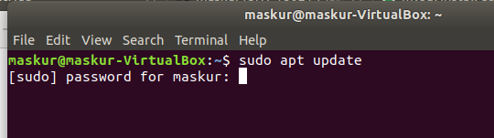
Then install the default package:
sudo apt install mysql-server
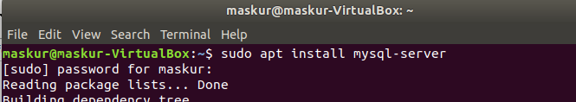
This will install MySQL, but will not prompt us to set a password or make any other configuration changes. Because this leaves our installation of MySQL insecure, we will address this next.

Step 2 — Configuring MySQL
For fresh installations, you’ll want to run the included security script. This changes some of the less secure default options for things like remote root logins and sample users. On older versions of MySQL, we needed to initialize the data directory manually as well, but this is done automatically now.
Run the security script:
sudo mysql_secure_installation
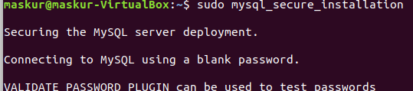
This will take us through a series of prompts where we can make some changes to our MySQL installation’s security options. The first prompt will ask whether we’d like to set up the Validate Password Plugin, which can be used to test the strength of our MySQL password. Regardless of our choice, the next prompt will be to set a password for the MySQL root user. Enter and then confirm a secure password of your choice.
From there, we can press Y and then ENTER to accept the defaults for all the subsequent questions. This will remove some anonymous users and the test database, disable remote root logins, and load these new rules so that MySQL immediately respects the changes we have made.

Step 3— Testing MySQL
Regardless of how we installed it, MySQL should have started running automatically. To test this, check its status.
Systemctl status mysql.service
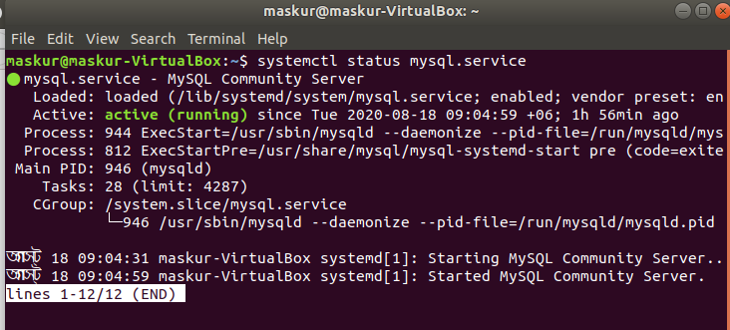
Log in into mysql :
using command sudo mysql and then enter the password.
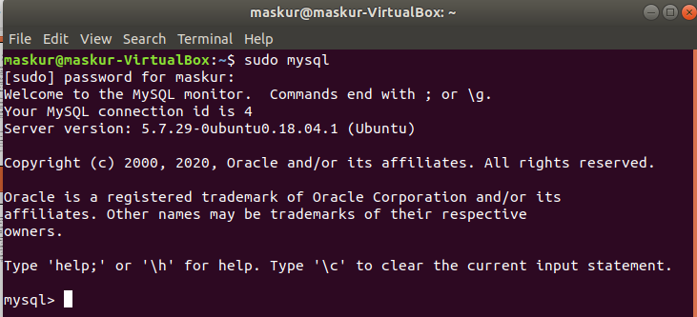
To see the database : show databases;
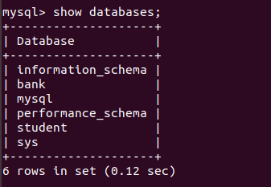

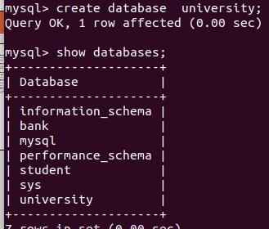
To create database : create database database_name ;

To create table : First select the database where we want to create the table using ‘use’ command and then use the following command to create a table.
create table table_name(column1 type , column2 type, ……..,column_n type);

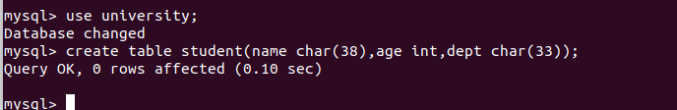
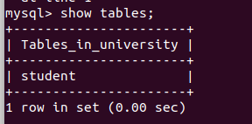
To see table list in a database : show tables;

To insert into table : insert into table_name values(‘value1’,value2, value3, …….,value_n);

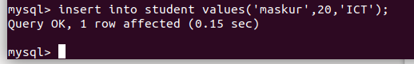
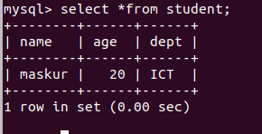
To show the table content : select *from table_name;

To see the specific column of a table : select column_name1 ,column_name2 … column_nameN from table_name;
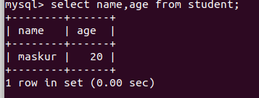

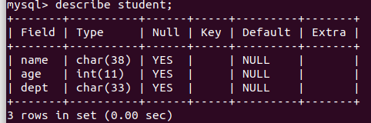
To describe a table : describe table_name or desc table_name;

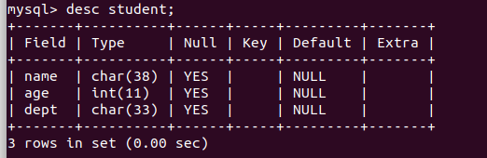

To alter any table : We use the alter table command to add attributes to an existing relation . All tuples in the relation are assigned null as the value for the new attribute. The form of the alter table command is
alter table r add A D ;
where r is the name of an existing table , A is the name of the attribute / column and D is for data type.
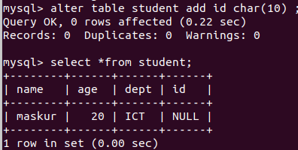

Here in the above command in the terminal we alter the student table adding a new column id which type is character type.
We can also drop a column using drop command in the place of add .
alter table r drop A ;
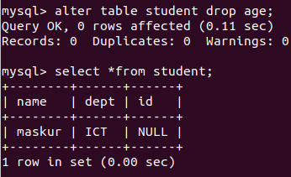

Here in the above command in the terminal we have dropped the age column .

We can rename the table we need to use the following command :
alter table R rename as N
where R is the existing table name and N is the new table name
So now look at the terminal where we change our student table to xstudent.
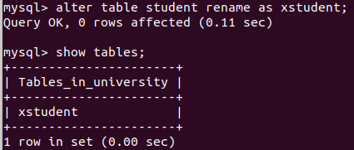

Modification :

Insertion : To insert data into a relation , we use the following command :
insert into table_name values(value1,value2,value3)
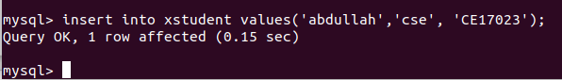
Here in the above command in the terminal we insert abdullah whose dept is cse with id CE17023.

Update :
In certain situation we may wish to change a value in a tuple without changing all values in the tuple . For this purpose, the update can be used.
Update table_name set column_name= new_value;
This query will affected all the tuple.
We can update a specific tuple only using where command.
Update table_name set colum_name= new_value where condition;

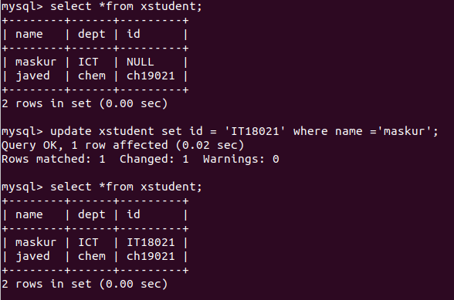

Delete & where clause : A delete request is expressed in much the same way as a query. We can delete only whole tuples; we cannot delete values on only particular attributes . SQL expresses a deletion by
delete from r where P;
where P represents a predicate and r represents a relation
Here are examples of SQL delete request:
> Delete all tuples in the xstudent table pertaining to xstudents in the cse department .
delete from xstudent where dept= ‘cse’ ;

